HIEv User Manual

For software version 1.8 %%% Confirm SW version number

%%% Date April 2013 | v1.2

%%% TODO:

Replace all screen dumps

MAC or Windows?

What example data and login account should be used for screen dumps?

Should screen dumps show functions only available to Admins?

There has been a significant rise in the number of sensors and sensor networks used in environmental research in recent years. This growth has brought with it the challenge of managing sensor infrastructure and the data produced by the increasing numbers of deployed sensors.

The HIEv system was developed to address these challenges and specifically aims to:

* Ensure raw data is never lost
* Ensure that data can be used and interpreted in the future
* Allow researchers to make linkages between different types of data
* Make it easier for researchers to get access to the data they need
* Make it easier for technical officers to distribute the data
* Create entries in Research Data Australia (required by ANDS)

As a web application, HIEv is easily accessed from a variety of locations and platforms – all you need is a modern web browser and the URL of the server hosted by the research centre with which you are affiliated /collaborating.

Contents

1 Overview 4

1.1 Installing HIEv 5

2 Logging in to the system 6

3 Viewing Data Files 8

3.1 Deleting a file 10

3.2 Editing a file's metadata 10

4 Creating a New Facility 12

5 Creating a New Experiment 14

5.1 Experiment Parameters 17

6 Uploading Data files 19

6.1 Uploading RAW TOA5 data files 22

6.2 Automating the upload of data to HIEv 22

7 Searching 23

8 Downloading and Deleting Files 30

9 Publishing a Collection 32

10 System Administration 34

10.1 The Users Tab 34

10.2 The Access Requests tab 35

10.3 The Column Mappings tab 36

10.4 Modifying Tags, Column Mappings and Experiment Parameters 38

10.5 Migrating data to a new system 40

11 Appendix A – Upload Scenarios 42

12 Revision History 44

1. Overview

HIEv is designed to act as a central repository for environmental research data. Technicians can configure their field PCs to automatically push time-series data from sensors into HIEv, while researchers can use the system to discover and download the latest data available. Rich metadata is stored for physical infrastructure (“Facilities”), the Experiments that run at those facilities, as well as the individual files to support discovery and interpretation.

DC21 Diagram

All files in HIEv are grouped by Experiment, providing a convenient way to organise related files such as cleansed or gap-filled data, and analysis outputs.

Once finalised, collections of data can be defined, described and published to ANDS. This enables researchers from outside the organisation that produced the data to discover it, and to request access to download a copy.

* 1. Installing HIEv

All instructions for installing and upgrading HIEv are held at [Deployment Guide](https://github.com/IntersectAustralia/dc21/wiki/Deployment-Guide) on the project’s [GitHub Wiki](https://github.com/IntersectAustralia/dc21/wiki).

1. Logging in to the system

To begin using HIEv, enter the system URL %%% What is it? into your web browser. Before you can login you are required to have a system account. You can apply for an account by clicking the blue "Sign Up" button on the top left of the screen:

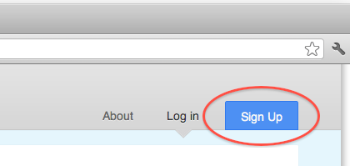

This will take you to a form where you will be requested to enter your first name, last name, email address and chosen password. (Note: Passwords must be between 6-20 characters and contain at least one each of: an uppercase letter; a lowercase letter; a digit and a symbol.)

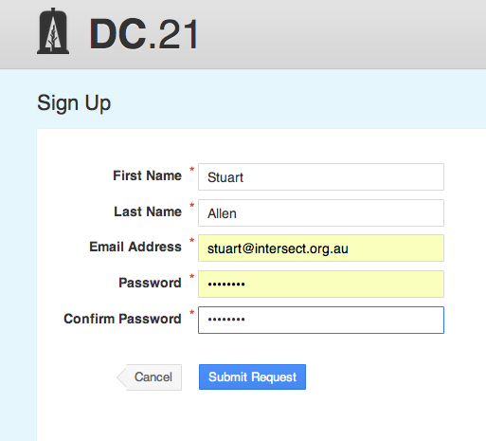

Once you have filled out the form and clicked "Submit Request" an email will be sent to the system administrator who will either approve or deny your request for access. If your request is approved you will receive an email informing you that you can now login using the password you entered on the original sign up form.

To see the login form, make sure you have the "Log in" tab selected on the top right. Next enter your Email address and password and click the blue "Log in" button below:

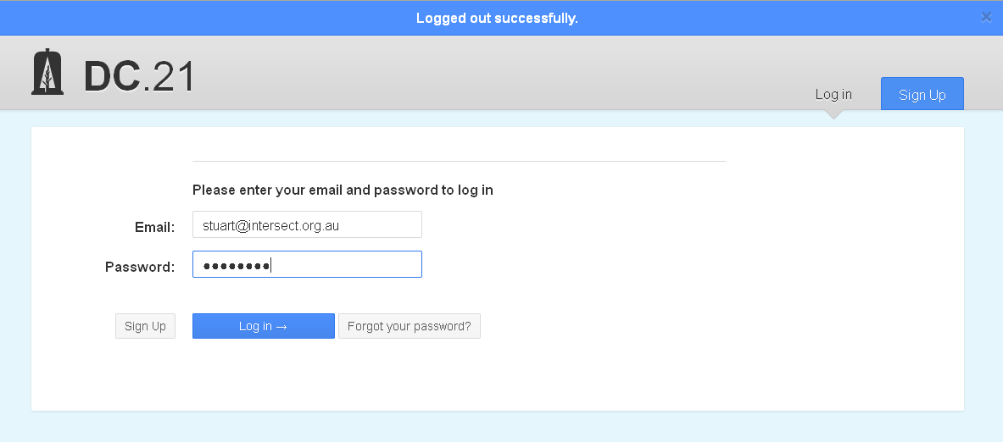

Once you have logged in you will be taken to the main screen for the HIEv application.

1. The HIEv Home Screen

The Home Screen consists of the following parts:

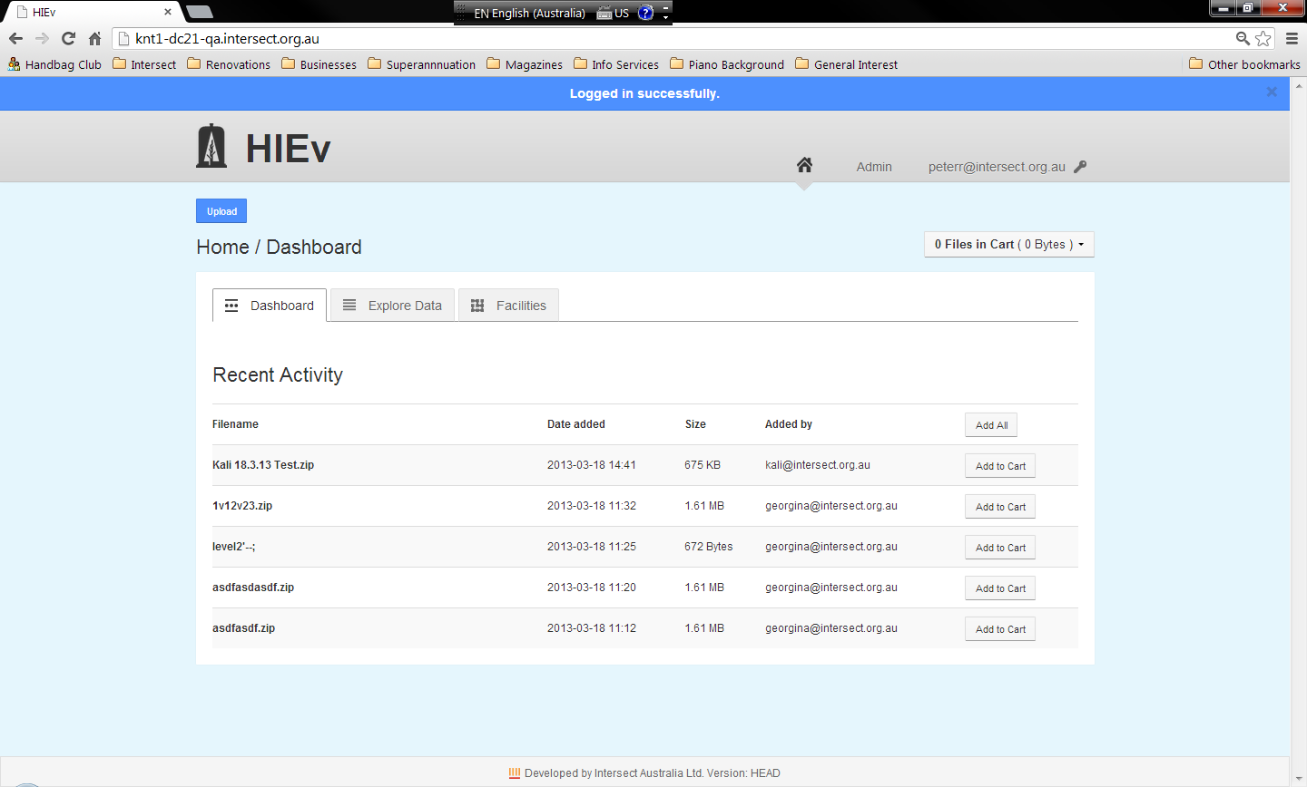HIEv Home Screen

%%% Add reference numbers to this diagram when the final cut & paste is done.

Most of these components are common to many screens in the HIEv system.

|  |  |  |
| --- | --- | --- |
| 1 | Home Button | Click to show the Home/Dashboard (as shown in the view above). |
| 2 | Admin Button | Click to access Admin functions (see Chapter %%%). This is only available if you have Administrator permissions. |
| 3 | Login ID | This is your logon name. Click to open a drop down menu of user operations. (See Section %%%.) |
| 4 | Action button | In many screens, there is an action button at the top left corner. It is often an Upload button, which allows you to upload new data files to HIEv. (See Chapter %%% for more information on Uploading.) However, it can also be other functions which are more relevant to the data being displayed in the current view. |
| 5 | Cart Status Box | The HIEv web interface allows you to add files to a Cart, which operates like an eCommerce shopping cart. Click in the Cart Status to open a drop down menu of Cart functions. (See Chapter %%%.) |
| 6 | Work Area | This contents of this work area changes as you perform HIEv operations. |
| 7 | Version Indicator | This shows the version of HIEv which you are accessing. |

* 1. Signing Out

Click on your login ID at the top right of the screen to see a drop down menu. Click on Sign Out to finish your HIEv session.

* 1. Changing Your User Settings

Click on your login ID at the top right of the screen to see a drop down menu. Click on Settings to access the following three tabs.

When finished, click on the Home button to return to the Home screen.

* + 1. Overview Tab

%%% What are tokens about?

* + 1. Edit Details Tab

%%%

* + 1. Change Password Tab

%%%

1. Managing Data Files

The key views of the files loaded into the HIEv database are the Dashboard and Explore Data views. These views allow you to perform the key functions of the HIEv system.

Access these views by clicking on their respective tabs on the HIEv Home Screen.

* 1. The Dashboard Tab

The default tab on the Home Screen is the Dashboard tab. It shows a list of files which have recently been uploaded by the users of the HIEv system.

The operation of the Dashboard tab is similar to the operation of the Explore Data tab, except that searching and sorting functions are not supported. Therefore, please see the description of the Explore Data tab for more information.

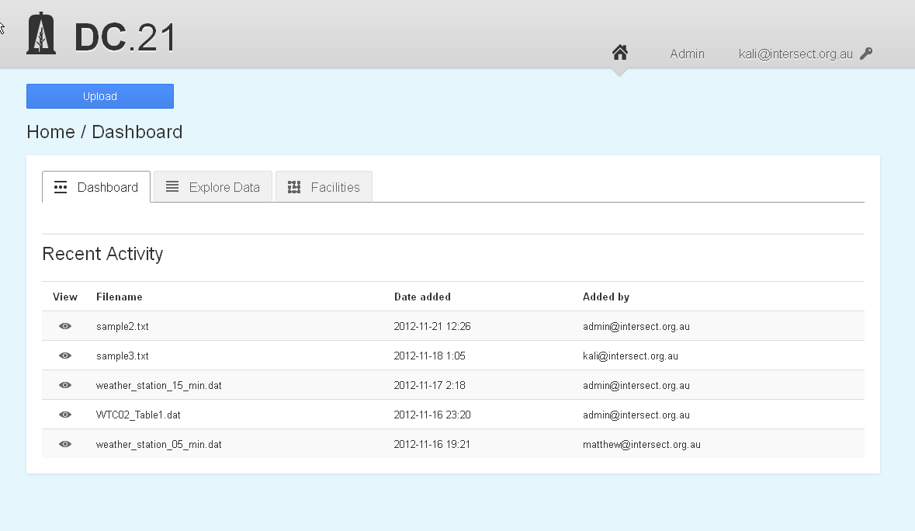

%%% Are there ever other sections besides “Recent Activity”?

* 1. The Explore Data Tab and File Searching

The Explore Data tab provide the main data management functions of the HIEv system. The initial view shows all data files which have been uploaded. If there are more than fit on one screen, only the first 30 files will be shown, and the subsequent files can be shown by paging through the data using the page number buttons.

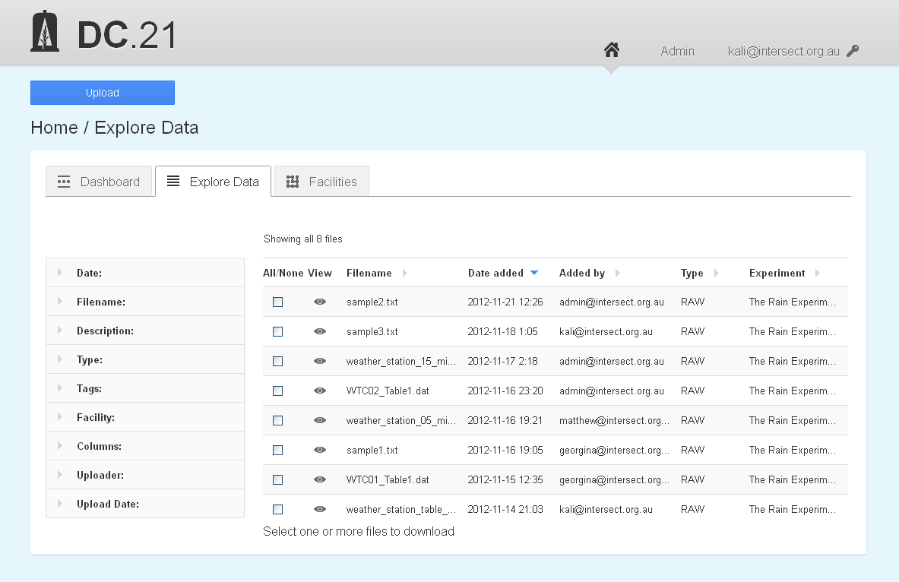

%%% Annotated screen dump

* + 1. Sorting

Click on the heading of any column in this view to sort the files into increasing order for that column. Click again to reverse the sort order.

The triangular arrows to right of the column headings indicate the active sort order. A grey right-pointing arrow indicates unsorted.

Re-sorting the data always resets the display to the first page.

* + 1. Searching

Once data files have been added to the system, they can be searched using the metadata that was supplied at the time of upload.

The left-hand column of the Explore Data tab contains fields to specify your search criteria. When this tab first opens, each field of the search interface is collapsed. Click on the field you wish to search by to expand it. Searches can be refined further by adding more search criteria to other fields.

The **Date** field allows you to search for files based on the start and end date of the data contained within the file:

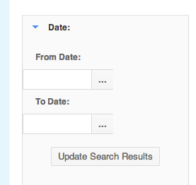

A date can be entered in either the **From Date**, **To Date** or both. If only a **From Date** is specified, all files containing data for after that date will be included. If only a **To Date** is specified, all files containing data for before that date will be included.

Dates can be typed into the **From Date** and **To Date** fields in *YYYY-MM-DD* format or by clicking on the ellipsis to the right and selecting a day from the calendar that is displayed:

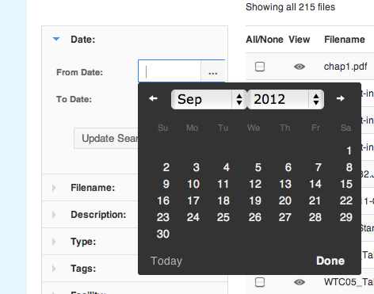

The **Filename** field allows you to search for files based on their filename:

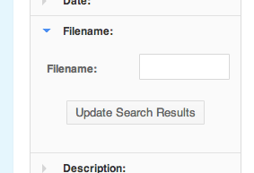

Once the search results are updated, only files that contain the supplied text string in their filename will be returned. This will include partial matches. For example, if the string ".txt" was entered, only files that have ".txt" in their name would be returned regardless of the rest of the filename.

The **Description** field allows you to search for files based on their free-form text descriptions:

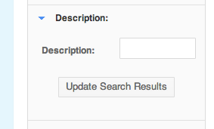

Like the filename search, the string supplied only needs to be a partial match with the description of a file for it to be included in the search results.

The **Type** interface allows you to search for files based on their specified type:

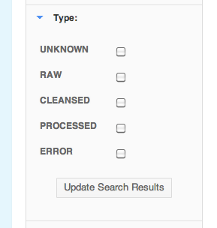

%%% Package check box and subsequent drop down options has now been added.

The set of possible types is displayed as a list of checkboxes. Selecting none of the checkboxes is the same as selecting them all - files will not be filtered based on their type. Once at least one checkbox has been selected only files of that type will be returned in the search results. More than one type can be selected at any given time.

The **Tags** interface allows you to search on the tags that have been given to a file:

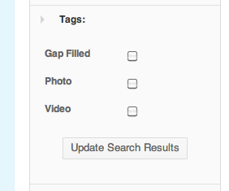

Like the Type interface, selecting none of the available checkboxes means that files will be returned in the search results regardless of the tags they have. Once a checkbox is selected, only files that have the corresponding tag will returned. More than one tag can be selected at any given time.

The **Facility** interface allows you to search for files based on the facility or experiment that produced the file:

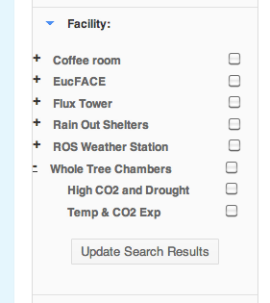

The interface is a two-level hierarchy of checkboxes. The top level represents all the facilities in the system and the second level represents the experiments that are running, or have run, at each of the facilities. Selecting a facility selects all of the experiments for that facility. If only specific experiments are required, clicking on the plus sign to the left of a facility will expand the hierarchy and allow individual experiments to be selected or deselected.

The **Variable** interface allows you to search for TOA5 format data files that contain the specified variables/ columns:

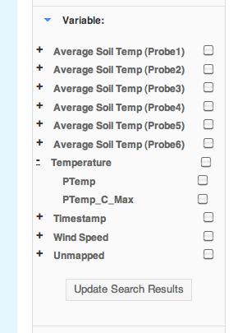

Like the Facility interface, the variable is a two-level hierarchy of checkboxes. The top level contains all the standardised variable names that column headers are mapped to. There is also a special top-level group called **Unmapped** that contains all the headers that are not mapped to a standard name.

Selecting the checkbox for a standardised top-level variable name will select all the variables (TOA5 column names) that are mapped to it. Clicking the plus sign to the left of the standardised variable will show all the columns mapped to it and allow you to select them individually.

The **Uploader** field allows you to search for files that were uploaded by a specific user: %%% This is now Added by:

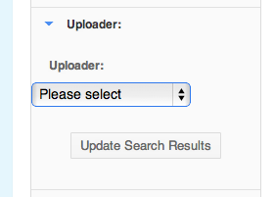

The user must be selected from a list of a users registered in the system.

The **Upload Date** interface allows you to search for files that were uploaded between a specified set of dates: %%% This is now Date Added:

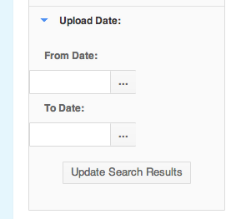

Like the **Date** field, the **Upload Date** interface allows you to select a **From date** and a **To Date**. If both dates are specified only files uploaded between those dates will be included in the search results. If only a **From Date** is specified, all files uploaded after that date will be included. If only a **To Date** is specified, all uploaded before that date will be included.

If any of the above fields in the search interface are left blank then files will not be excluded from the search results based on their criteria. If more than one field has search criteria specified then only files that match all the specified criteria will be returned.

* 1. The Cart

The Cart operates like an eCommerce shopping cart. HIEv provides functions for adding files to the Cart and for doing operations, such as Downloading and Publishing, on all files in the Cart. See more information about Downloading in Chapter %%% and Publishing in Chapter %%%.

Add a file to the Cart by clicking on any Add to Cart button for that file. There are Add to Cart buttons in multiple places, including the Dashboard file list and the Explore Data file lists.

Click on the Cart Status box, which appears at the top right of the Home Screen, to show a drop down menu of operations which can be performed on the files in the Cart. These operations are:

|  |  |
| --- | --- |
| Download | Click on this option to download data files to your local computer. See Chapter %%%. |
| Package | Click on this option to create a publishable package containing all files in the cart. See Chapter %%%. |
| Clear cart | Click on this option to remove all files from the Cart. |
| Edit cart | Click on this option to view the Cart contents, remove individual files from the Cart, download all files in the Cart or create a publishable package using all files in the Cart. See Section %%% for more details. |

* + 1. Editing the Cart

%%%

* 1. Viewing and Editing a File's Metadata

Clicking on any Filename in the left hand column will display the metadata for that file in a screen similar to the following:

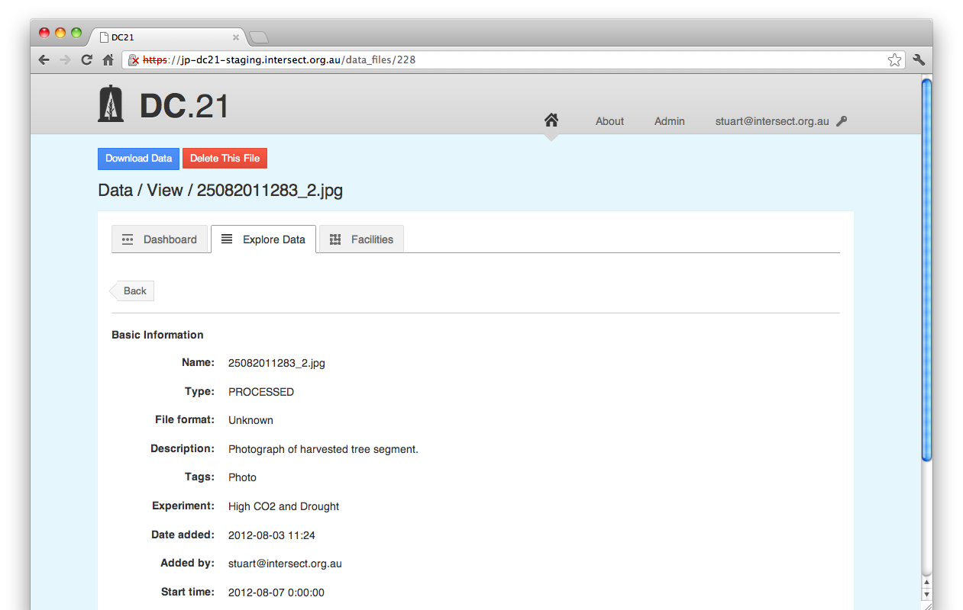

The **Name** field shows the name of the file as it is stored in the HIEv system.

The **Type** of the file is a single value that describes the data contained within the file. This value is chosen from a constrained list of possibilities defined by the system administrator. The file's **Type** is generally aimed at tracking data through its various stages of processing.

The **File format** indicates if the HIEv system was able to inspect the contents of the file and determine the internal structure. Currently the only format understood by the HIEv system is TOA5.

The **Description** field is a human-entered description of the file.

The file **Tags** are a set of flags that have been given to the file from a constrained list of possibilities defined by the system administrator.

The **Experiment** field indicates which experiment produced the file. Each file must be associated with exactly one experiment. Any user with the appropriate permissions can create experiments.

The **Date added** filed indicates the date that the file was uploaded and the **Added by** field indicates the user that uploaded the file.

The **Start time** and **End time** fields indicated the range of the data contained within the file. For non-TOA5 these dates must be manually entered by the uploader. For TOA5 file this information is automatically extracted from the file itself along with the follow extra pieces of information:

The **Sample interval field** specifies the frequency of samples in the data file if relevant .

The **Datalogger model** field specifies the model of data logger used to generate the TOA5 file.

%%% There are other fields, such as Facility, Size, Added by. Are Start time and End time still displayed? Aren’t the fields displayed dependent on the type of the file? There is also Information From The File and Column information. Should we bother to carefully define only such a small selection of the possible displayed data? Where are the Column Mapping contents and Units and Measurement Type abbreviations explained or defined?

%%% Also Add to Cart from this screen, but Cart functionality may not be defined until later in the doc, so forward reference.

There is a button which says Add to Cart. Click this button to add this file to your Cart. If the file is already in your Cart, then the button will change to say Remove from Cart, and you can use it to remove the file from your Cart.

At the bottom of the screen is a button to edit the file's metadata:

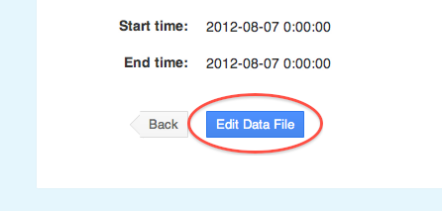

This button will take you to a form that allows you to modify the file's metadata:

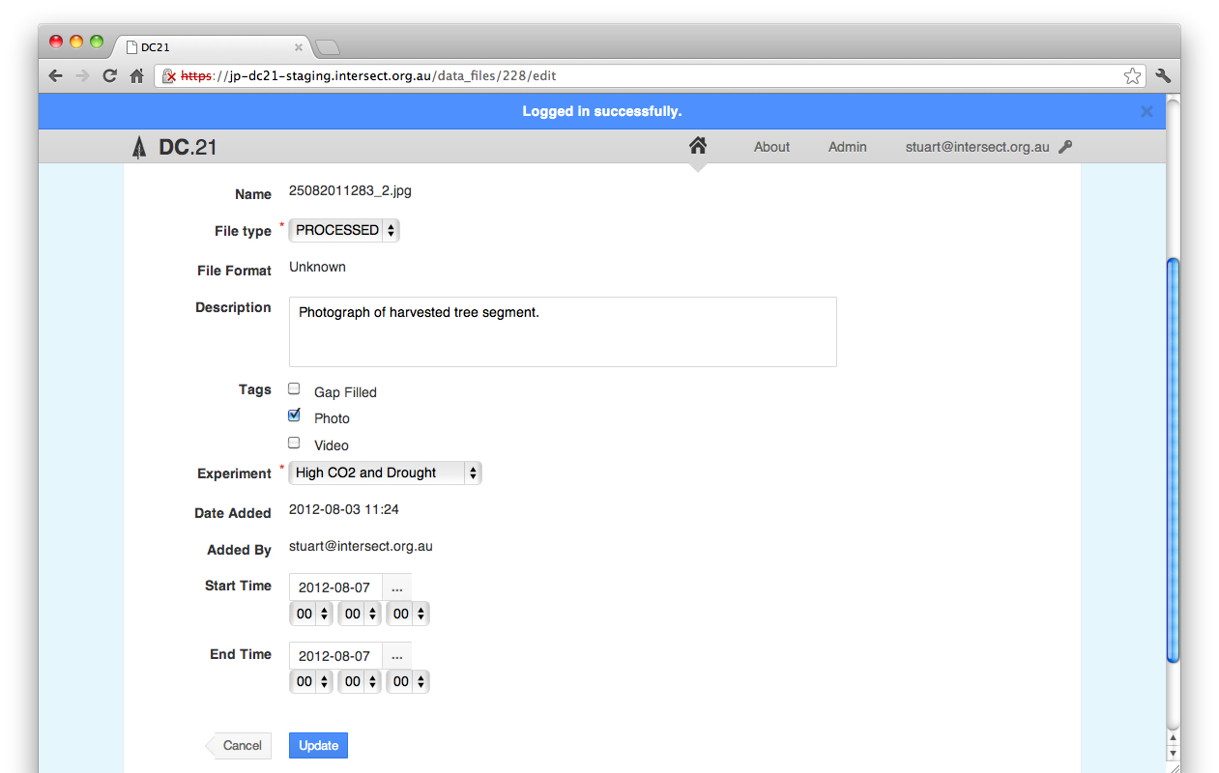

Once you have finished editing the metadata, click the "Update" button to save your changes.

* 1. Deleting a file

In order to delete a file from the HIEv database, first view the metadata for that file by clicking on the file name in either the Dashboard or Explore Data views. If you have permission to delete that file, a red Delete This File button will appear at the top of the Metadata View screen.

Note You will only have permission to delete this file if you are logged in with the user credentials which were used when the file was uploaded, or you have Administration permission.

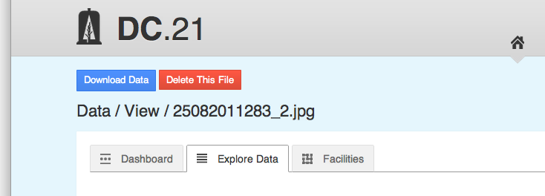

When you click on the Delete This File button, you will be asked to confirm that you do wish to delete the file.

Deleting files removes the file completely from the HIEv system. It is irreversible.

* 1. Downloading files

%%% This is substantially changed, and probably needs to be integrated into the description of Carts, or similar.

Files on the "Explore Data" tab can be downloaded by selecting the checkbox on the left-hand side beside the files you require and the clicking the "Download Selected Files" button at either the top or the bottom of the tab:

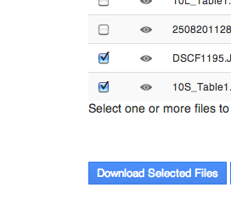

This will give you the option to open or save the file "download_selected.zip" to the computer you are accessing HIEv from. This zip file, when expanded, will contain each of the selected files and a metadata directory. This metadata directory will contain text files with human-readable metadata for each of the files *<FileName>***-metadata.txt** and the facilities and experiments that produced those files: *<Facility>***-metadata.txt** and *<Experiment>***-metadata.txt**

Individual files can also be downloaded by clicking on the file from the "Explore Data" or "Dashboard" tab to view the file's metadata and then clicking the "Download Data" button at the top left:



Files can only be deleted one at a time by using the "Delete This File" button at the top of the page displaying the file's metadata. Users can only delete their own files. Administrators can delete all files.

* 1. Publishing Your Data

Once an experiment is complete, the data collected can be published to the [Australian Research Data Commons](http://www.ands.org.au/about/approach.html#ardc). Exactly how a collection is defined is largely dependent on what is a meaningful for the data and research discipline in question. It is entirely valid to have the same data appear in multiple collections if that will aid discovery and reuse for other researchers. For example, a large set of data could be divided into two smaller, but overlapping, sets of data that represent different lenses (research problems) that the data could be seen through.

At any time, a set of files in HIEv can be published as a collection by going to the Explore Data tab, & conducting a Search to locate the desired files in the Search results, & selecting the checkboxes for the files that should be included in the collection, and then clicking the "Publish Selected Files" button at either the top or the bottom of the Explore tab Search results (%%% Note: Later HIEv development will allow users to Publish data files without first Searching).

This will display a form where you will be prompted to supply a name and description for the collection. The name should be a full sentence that describes exactly what the collection is, for example: "Flux data and supporting measurements relating to tree water use, carbon uptake and growth in a high temperature and high CO2 environment." The description field should contain enough information to understand how the data in the collection was produced. This is likely to involve making use of parts of the metadata for the Facility and Experiment that produced the collection:

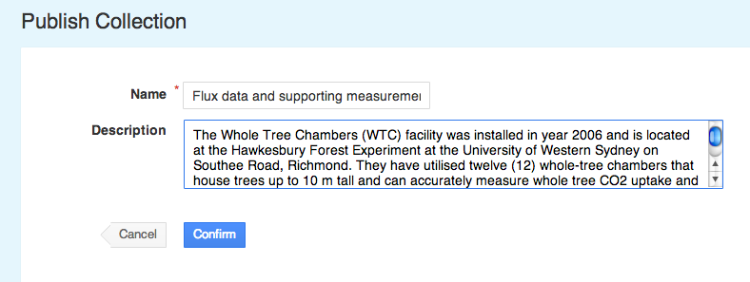

When a collection is published, an XML file containing a description of the collection is produced along with a ZIP file containing all the files and relevant metadata. This ZIP file is identical to the one that would be produced had the "Download Selected Files" button been clicked instead. When the Confirm button is clicked you will be returned to the "Explore Data" tab with a confirmation message at the top of the screen:

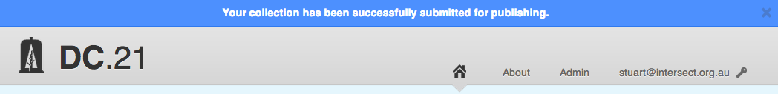

* + 1. Creating a Package
    2. Publishing a Package
    3. Viewing Published Packages

The descriptions of published collections can be viewed by going to the jOAI web interface at **http://<***your.HIEv.sever>***/oai/admin/query.do** and performing a search:

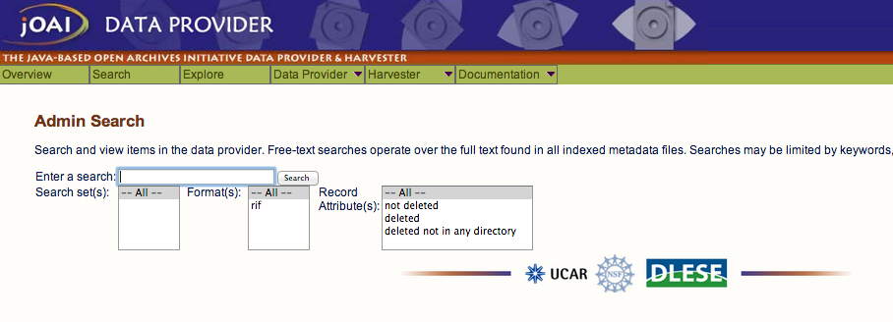

Clicking the search button with the search field blank will show all published collections:

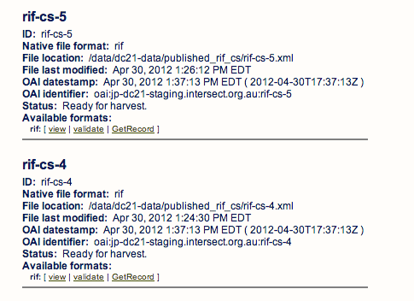

Once a Collection has been published the metadata describing the collection will be made available for harvesting by the UWS Metadata Store. After this has occurred and the collection approved it will become discoverable in [Research Data Australia](http://researchdata.ands.org.au/).

1. Facilities and Experiments

All data files uploaded to the HIEv system must be associated with an Experiment. In turn, all Experiments are associated with a Facility.

Therefore entries for Facilities and Experiments must be created before the associated data files are uploaded.

* 1. Creating and Editing Facilities

A Facility represents any instrument, or discrete set of instruments that are used in concert. This could be a multi-million dollar fixed facility with hundreds of instruments and sensors or a single piece of portable equipment that is taken out into the field.

Note Take care. Once created, a Facility entry cannot be deleted. This prevents data files which reference this Facility from becoming invalid.

Facilities are added by clicking the "New Facility" button at the top-right of the Facilities tab:

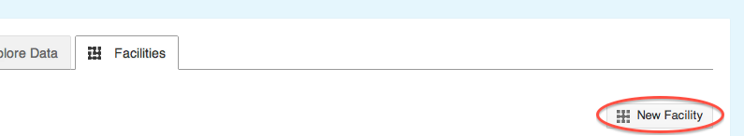

This will display a form that allows you to add details about the facility you would like to create:

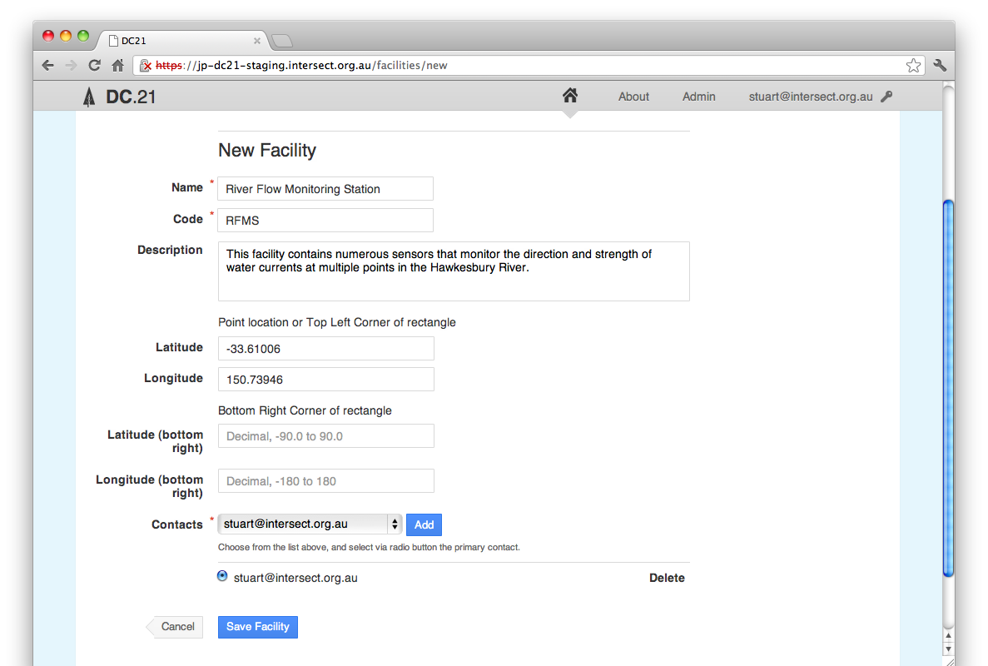

The **Name** for the facility is a short, plain-English title that will be used in the application interface to refer to the facility.

The **Code** for the facility is a short unique string.

The **Description** of the facility should be as comprehensive as possible describing details that would help a researcher both discover the facility when searching and assist the researcher in being able to interpret the data that is produced by the facility. These details would include things such as:

* The purpose of the facility
* Types of sensors installed at the facility
* Location of the sensors within the facility

The **Latitude** and **Longitude** for the facility are expressed in Decimal Degrees (<http://en.wikipedia.org/wiki/Decimal_degrees>) and can be taken directly from Google Maps. If a single set of co-ordinates are given that is considered to be the central point for the facility. If two sets of co-ordinates are given they are considered to be a rectangle that bounds the facility.

The **Contacts** for the facility must be selected from the users registered within the HIEv system. There must be at least one primary contact for each facility.

%%% The Contacts Add button needs explanation, and also the scope of the Contacts List.

Once facilities have been created they will appear on the Facilities tab:

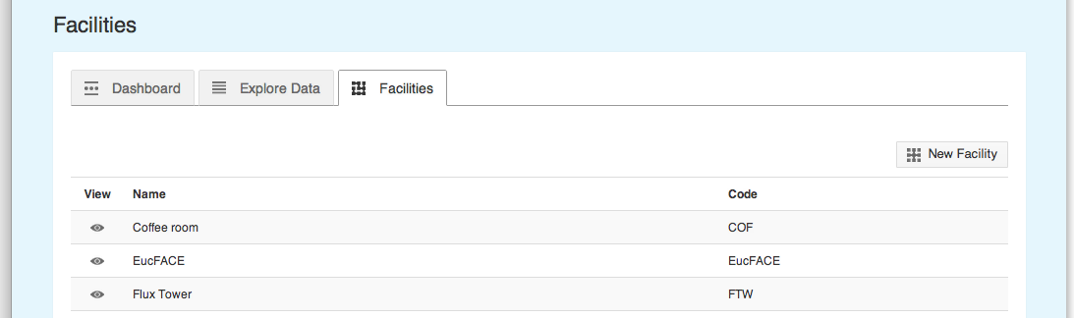

* 1. Creating and Editing Experiments

Before data can be uploaded into a HIEv system at least one Facility and Experiment must be defined. To define an Experiment, start by selecting the Facility where it will be running.

Note Take care. Once created, an Experiment entry cannot be deleted. This prevents data files which reference this Experiment from becoming invalid.

This is done from the Facilities tab by clicking the "Eye" icon in the left-hand View column beside the desired facility. This will display the information page for the selected facility:

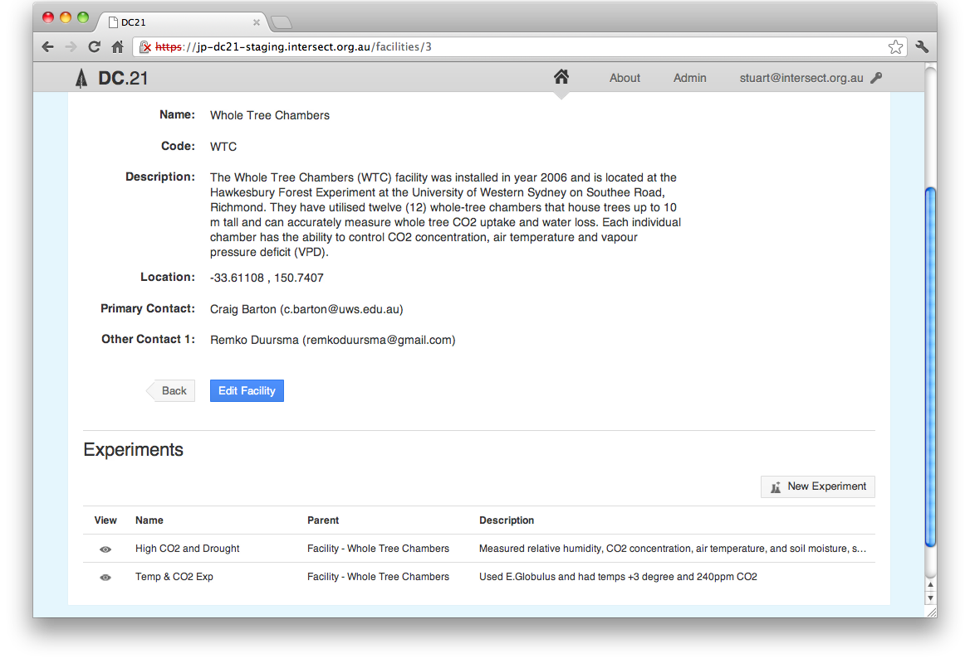

When viewing a facility, any experiments defined for that facility are listed below it. At the top-right of the experiment list is a "New Experiment" button.

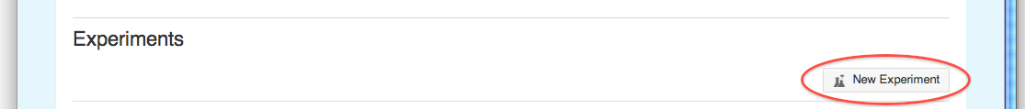

Clicking this button will display a form prompting you for all the information needed to create a new experiment under the current facility.

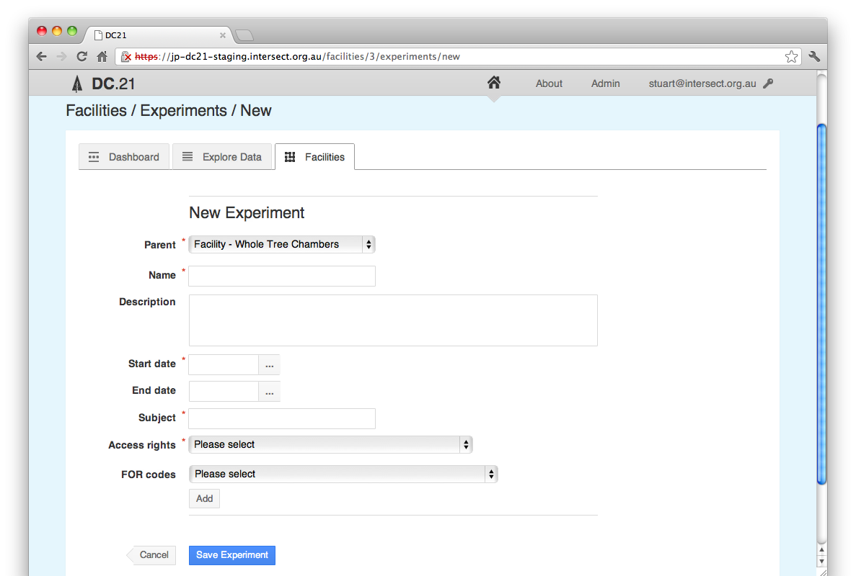

The **Parent** for an experiment is either the current facility, or another experiment running at that facility. If an experiment is selected, the new experiment is considered a sub-experiment of the one selected.

The **Name** for the experiment should be short, but descriptive enough to uniquely identify the experiment, including distinguishing an experiment from those that are likely to come in the future.

The **Description** for the experiment should describe the purpose of the experiment and the techniques employed. Particular focus should be given to aspects of the experiment that produce data that is stored in this system.

The **Start date** for the experiment is the date that experiment was first considered to be active.

The **End date** for the experiment is the date that the experiment concluded. This field should be left blank for experiments that are currently active.

The **Subject** for the experiment is a short phrase describing the experiment's main research area. The Subject is primary recorded to support publication to [ANDS](http://www.ands.org.au/guides/cpguide/cpgsubject.html) and in their own words, “A subject is a term, keyword, classification code or phrase representing the primary topic or topics covered by a registry object.”

The **Access rights** drop down list box provides a selection of licenses to release the data from this experiment under. It is preferred in Australia that data is released under a [Creative Commons](http://creativecommons.org.au/learn-more/licences) license.

Each experiment can have one or more **FOR codes**. The Fields of Research is a hierarchical classification with three levels, namely Divisions (two digits), Groups (four digits) and Fields (six digits). A unique number identifies each level.

Each Division is based on a broad discipline. Groups within each Division share the same broad methodology, techniques and/or perspective as others in the Division. Each Group is a collection of related Fields of research. Groups and Fields of research are categorised to the Divisions sharing the same methodology rather than the Division they support.

Codes are selected two digits at a time using the following interface. Codes can be specified to two, four or six digits but selecting options from the drop-down list boxes and clicking "Add".

Once an FOR code has been added it will appear below the list boxes and more FOR codes can be added.

FOR codes that have been added can be deleted by clicking the "Delete" button to the right of the code.

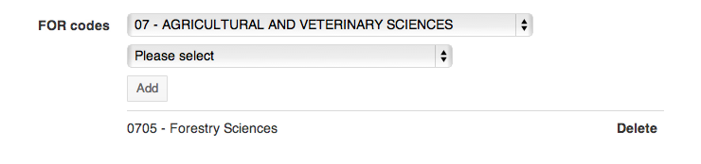

When you have finished adding all the required FOR codes, click "Save Experiment" at the bottom of the page:

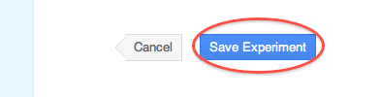

To abort creating the experiment, click "Cancel".

* 1. Setting Up Experiment Parameters

Experiments can optionally have one or more experiment parameters. These parameters provide a structured way to describe experimental treatments such as raising the CO2 within the tree chambers. Parameters are added by clicking the "New Parameter" button directly below the experiment:

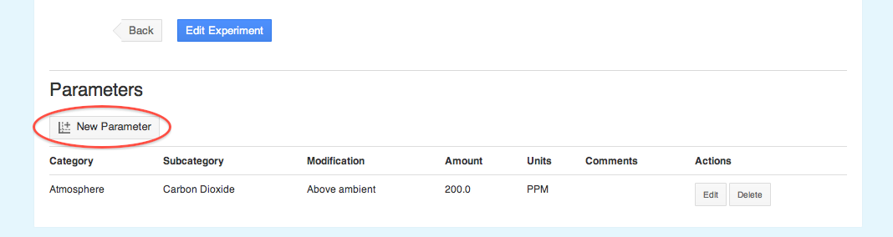

This button will display the form below:

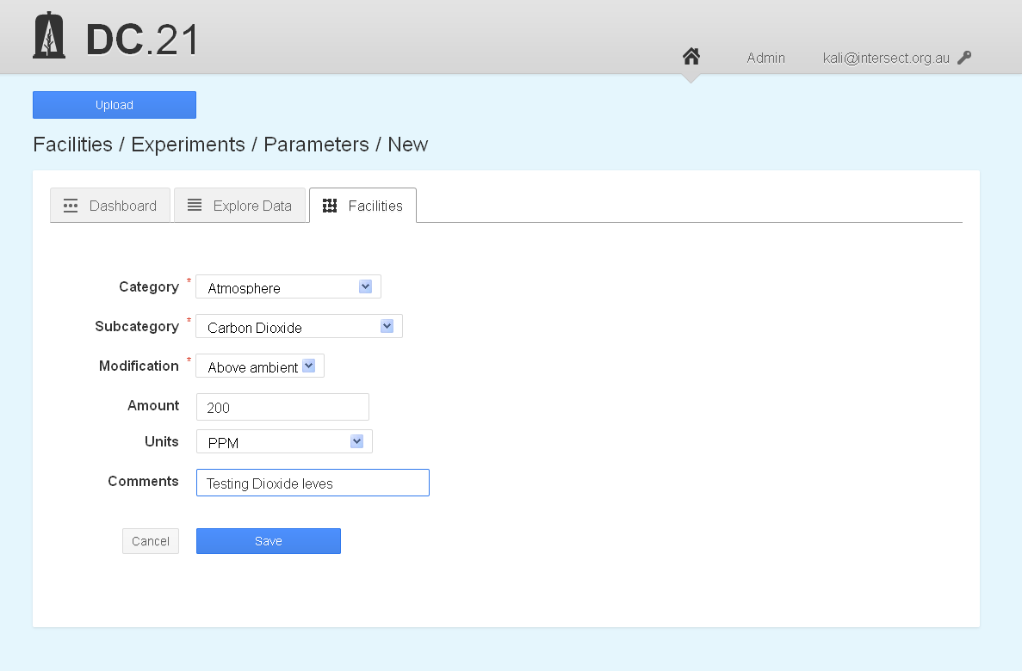

The first three fields are mandatory. The **Category** and **Subcategory** fields allow you to specify the medium that is being modified. The system administrator configures the values available in these dropdown list boxes.

The **Modification** indicates the general way in which the medium has been modified. The optional **Amount** and **Units** fields allow more specific information to be recorded about modification.

The **Comments** field can be used to record any unstructured, plain-text information you would like to record about the treatment

To finish, click the blue **Save** button at the bottom of the form.

Once an experiment parameter has been created it will appear below the main description of the experiment:

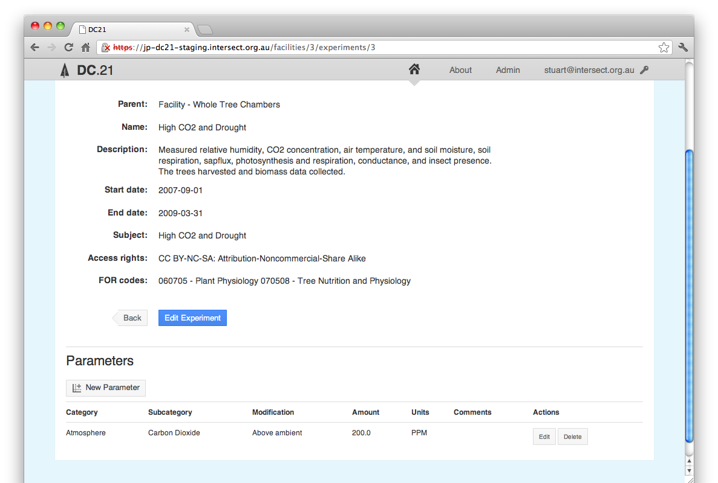

An experiment can have multiple parameters or none at all. Existing experiment parameters can be edited or deleted using the appropriate button to the right of the parameter in the **Actions** column.

1. Uploading Data files

New files are added to the system using the blue **Upload** button at the top left of the screen:

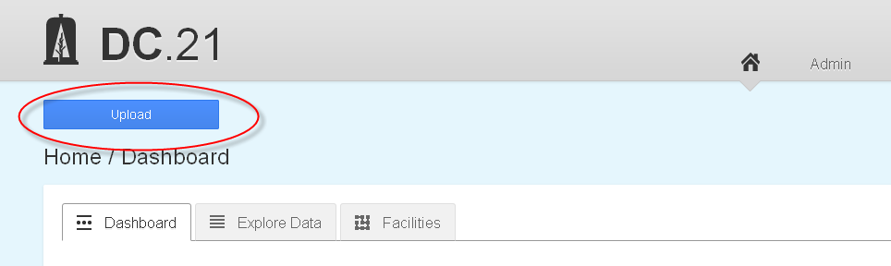

Clicking this button will take you to the "New Data Files" form:

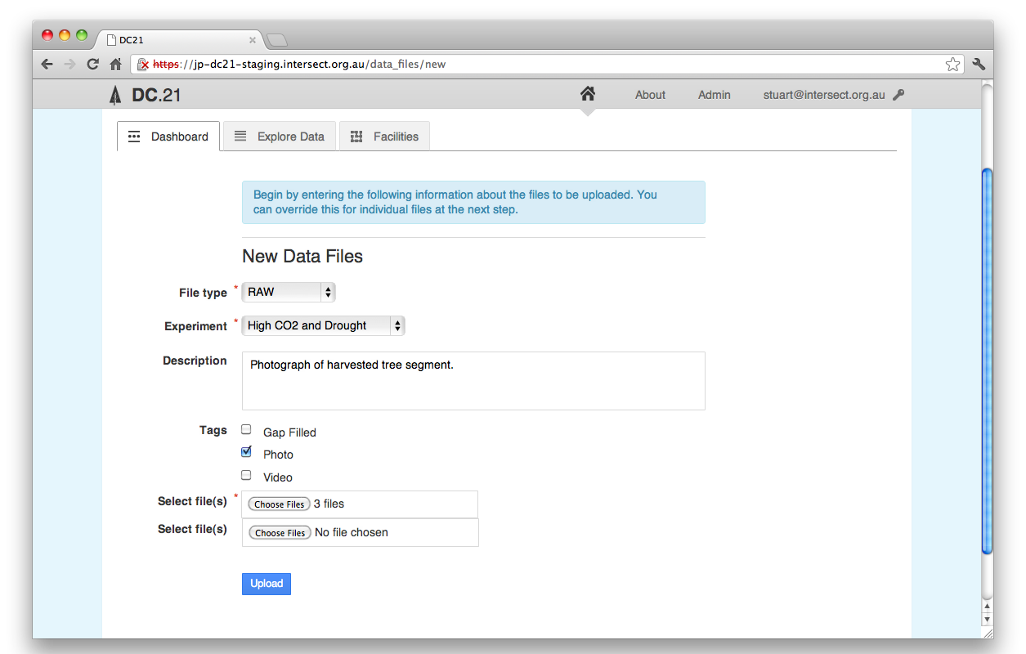

On this form you will enter all the metadata for the new file or files and also select the files to be uploaded.

The **File Type** is chosen from a set of fundamental types of data that has been defined by the system administrator. These are aimed at helping track data through its various stages from raw through various stages of processing. Please note that files that are uploaded with a File Type of **RAW** and are also detected as containing valid TOA5 header information are treated as a special case. See the end of this section for more information.

The **Experiment** for the file indicates which experiment produced the file. This is the primary mechanism by which files are grouped and associated with each other.

The **Description** for the file should contain enough information to understand the data within it. This will vary widely depending on the type of file but would typically contain information on the variables collected. Note that TOA5 files will have this variable information extracted automatically.

The **Tags** for the file are also chosen from a set defined by the system administrator. Where a file must have only one File Type, it may have any number of the available tags.

Once all the metadata has been entered and the files have been selected, click the blue Upload button at the bottom of the form. After the file or files have successfully uploaded, the supplied metadata will be applied to all uploaded files and you will be presented with the option to edit each file’s metadata individually:

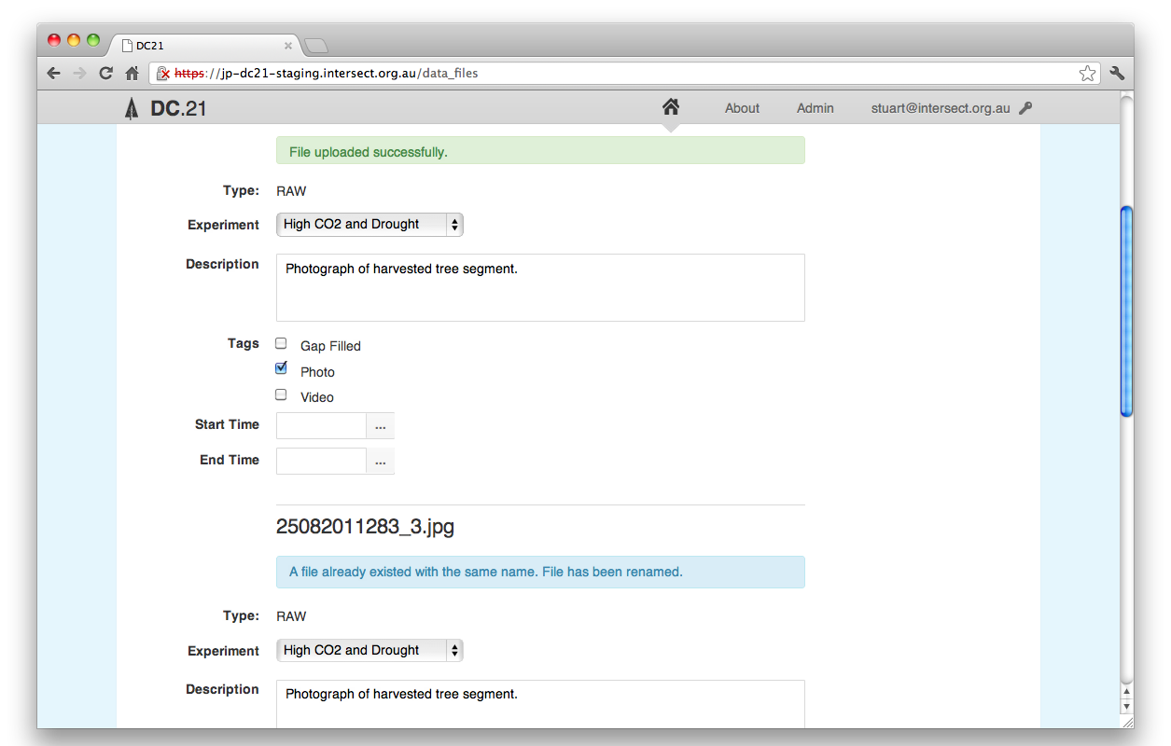

The metadata supplied is applied to all the uploaded files. Once the files are uploaded you are presented with the opportunity to make changes on a file-by-file basis. This is useful, for example, where you wish to give ten files the same description but add an extra tag to one of the files.

Once a file have been uploaded, if the start and end date for the data cannot be automatically extracted for the file (such as with TOA5 files), you are presented with the opportunity to enter this information manually:

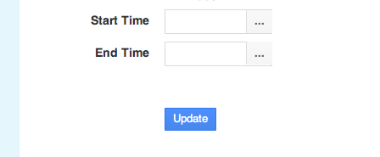

Dates can be typed into the **Start Time** and **End Time** fields in *YYYY-MM-DD* format or by clicking on the ellipsis to the right and selecting a day from the calendar that is displayed:

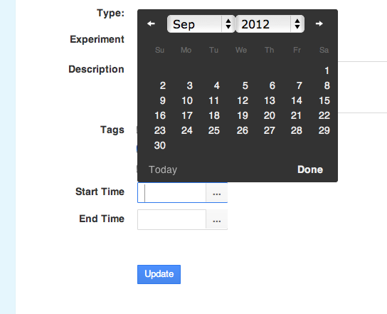

If an uploaded file has the same filename as another file that already exists within the system, HIEv will automatically suffix a unique number onto the end of the original filename, just before the file extension.

* 1. Uploading RAW TOA5 data files

When a TOA5 CSV file is uploaded with the **Type** of RAW, it is considered to become part of the canonical stream of data for that data logger. As a result, there will only ever be a single file with a **Type** of RAW that contains any given sample from a TOA5 data logger.

This has the affect that:

1. If TOA5 file is uploaded with a **Type** of RAW, and the file being uploaded is a complete superset of another file (or files) that are also RAW TOA5 files from the same data logger, the subset files will be replaced with this new file, regardless of the file names.
2. If a TOA5 file is uploaded with a **Type** of RAW that only partially overlaps and existing file of RAW data from the same data logger, the file will be uploaded, but its **Type** changed to ERROR and the original file(s) left in place.
3. If a TOA5 file is uploaded with a **Type** of RAW that overlaps and existing file of RAW data, but does not pass a sample-by-sample comparison with the original file(s), the file will be uploaded, but its **Type** changed to ERROR and the original file(s) left in place.
   1. Automating the upload of data to HIEv

As well as the web interface, data can be uploaded to the HIEv system using an HTTP-based API. The upload of data into the system is facilitated through a Ruby script. Instructions and a download for using this script can be found at <https://github.com/IntersectAustralia/dc21/wiki/Setting-Up-Automated-Load-From-PC> %%% Check this URL

1. System Administration

When a user is created they are given a role within the HIEv system. This role dictates what permissions the user has within the system. The most powerful role a user can be given within the system is that of the System Administrator.

All System Administrators have access to the Admin section accessed from the **Admin** link at the top right of the screen (only visible for this role). The Admin section has three tabs: Users, Access Requests and Column Mappings.

* 1. The Users Tab

The **Users** tab lists all the users that are registered within the system:

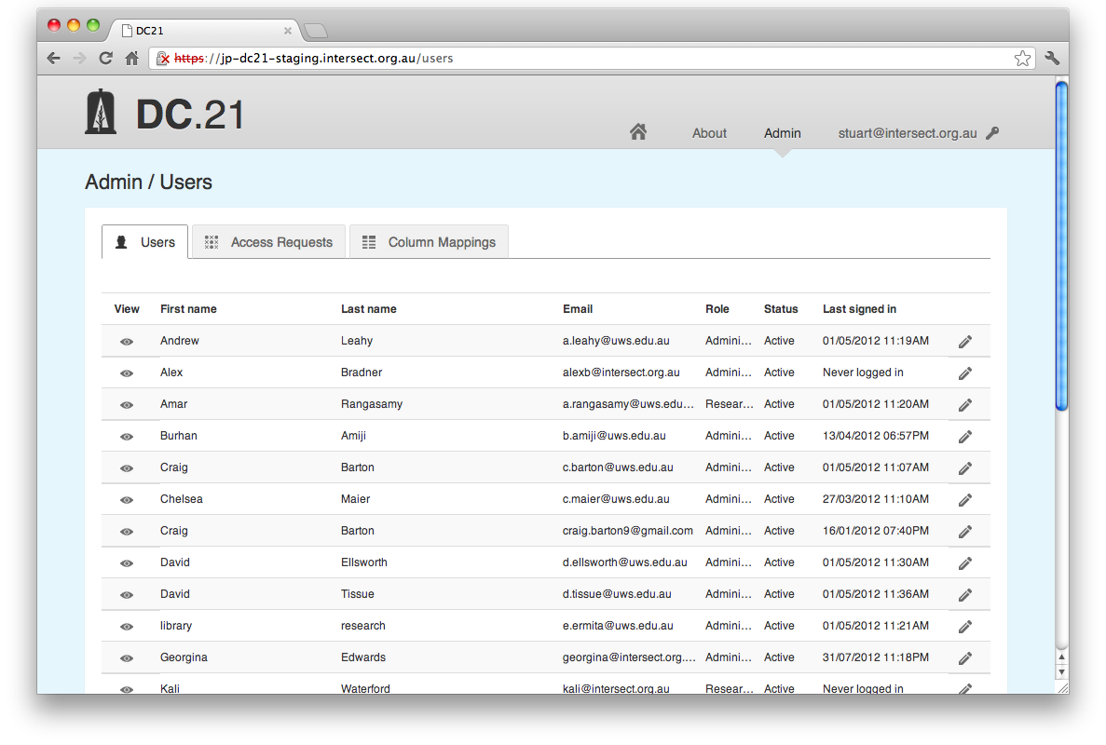

%%% The “Eye” is removed, but functionality remains essentially unchanged.

Clicking the "Eye" icon to the left of any user will display his or her details in full:

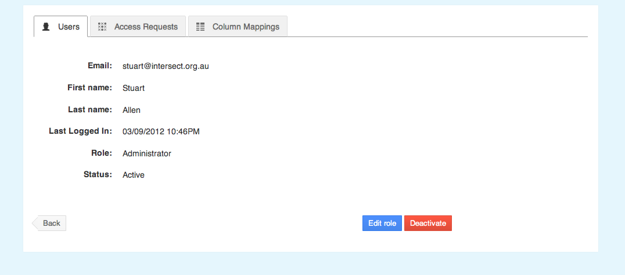

Clicking the **Deactivate** button will disable the account from being used to login to the system. No data uploaded by the user will be deleted.

Clicking the **Edit role** button allows the administrator to change the role that has been assigned to the user being viewed:

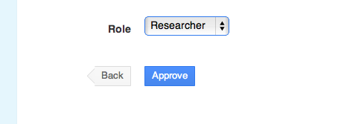

Any given user can only have a single role.

* 1. The Access Requests tab

The **Access Requests** tab is where an administrator can approve or deny requests for a user account in the system:

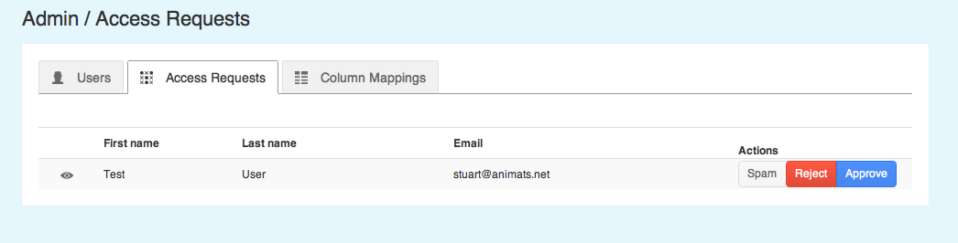

Selecting **Spam** will simply delete the account request from the system.

Selecting **Reject** will inform the user that his or her request for an account has been rejected.

Selecting **Approve** with take you to a screen where you must select a role for the user in the system:

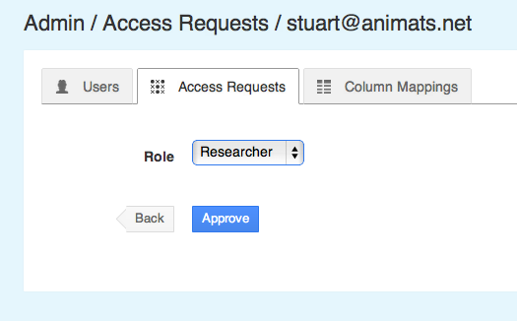

Once an account type has been selected and the account approved, the user will receive an email notifying them that they may now log into the system.

* 1. The Column Mappings tab

Column mappings are a way of defining a relationship between the column headers in TOA5 files (the "Code" part of the mapping) to a standard name from a defined ontology (the "Name" part of the mapping.) The **Column Mappings tab** allows the administrator to add and delete column mappings.

To delete an existing mapping, simply click the cross in the far right **Actions** row of the table for the mapping you wish to delete:

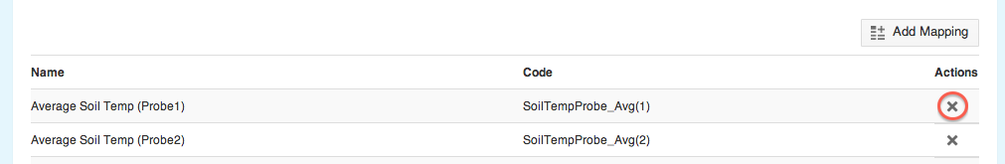

To add more mappings click the **Add Mappings** button at the top right of the tab. This will display a form where the mapping pairs can be defined. On the left of each row the code from the TOA5 column header can be entered and on the right the standard name to map to can be selected from a drop-down list box:

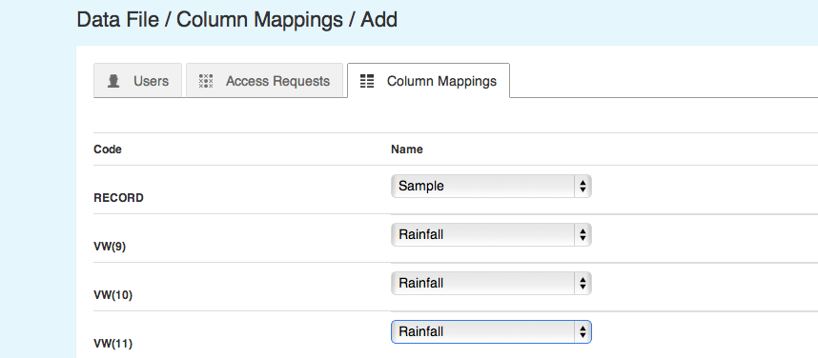

Once the mappings are defined click the **Submit Column Mappings** button:

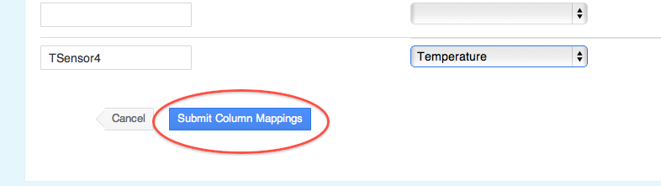

Column mappings may also be defined using the **Fill In Column Mappings** button on the **View Metadata** page for any given TOA5 file. This is the preferred method as it avoids the need to manually type the column headers into the "Code" fields:

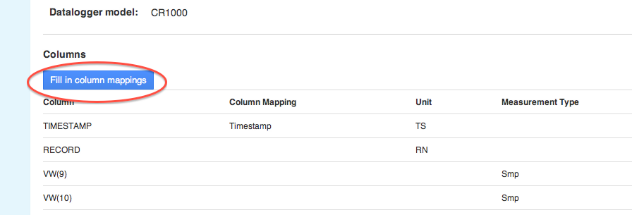

1. Modifying Tags, Column Mappings and Experiment Parameters

When HIEv is first installed, the available Tags, Column Mappings and Experiment Parameters are populated in the database from the configuration file: dc21app_extra_config.yml %%% Check file name. Once the system has been installed, the experiment parameters and tags can be modified by modifying the lookup tables that store these values. This can be done directly using a tool like PSQL. Another convenient way to do this is to use the Rails console. The instructions below use the Rails console to add rows to the tables.

If you wish to delete or modify existing rows in these tables, make sure you maintain referential integrity with existing records.

To begin, ssh to the server the HIEv system is running on. Once connected, the first step is to determine the Rails Environment the system is running as. This will generally be “production”, but you can check by looking for a RailsEnv line in the Apache Rails configuration (eg. <root>/etc/httpd/conf.d/rails_dc21app.conf %%% Check this file name). This will look something like the following:

RailsEnv production

In this case, the Rails Environment is "production". Once the value of this setting has been determined for you system, navigate to the location of the application installation (e.g <root>/home/devel/dc21app/current %%% Check this file name) and enter the directory "dc21app/current" %%% Check this file name. From here you can start the Rails Console using the command:

RAILS_ENV=<RailsEnv> bundle exec rails console

e.g.

RAILS_ENV= production bundle exec rails console

This will give you a prompt similar to:

Loading production environment (Rails 3.1.1)

1.9.2p290 :001 >

From this prompt you can issue commands to add Tags and Experiment Parameters.

To add a Tag use the command:

Tag.create!(name: '<Tag name>')

eg.

Tag.create!(name: 'Analysed')

This will result in output similar to:

(0.3ms) BEGIN

(1.3ms) SELECT 1 FROM "tags" WHERE LOWER("tags"."name") = LOWER('Analysed') LIMIT 1

SQL (8.7ms) INSERT INTO "tags" ("created_at", "name", "updated_at") VALUES ($1, $2, $3) RETURNING "id" [["created_at", Fri, 14 Sep 2012 10:55:24 EST +10:00], ["name", "Analysed"], ["updated_at", Fri, 14 Sep 2012 10:55:24 EST +10:00]]

(0.6ms) COMMIT

=> #<Tag id: 6, name: "Analysed", created_at: "2012-09-14 00:55:24", updated_at: "2012-09-14 00:55:24">

To add a Modification or a Unit for an Experiment Parameter, use the commands:

ParameterModification.create!(name: 'Above average')

ParameterUnit.create!(name: 'PSI')

Parameter Categories and Sub Categories require an extra step to define the relationship between the two:

parameter_category = ParameterCategory.create(name: 'Light')

parameter_category.parameter_sub_categories <<

ParameterSubCategory.create(name: 'Brightness')

This will result in output similar to:

1.9.2p290 :001 > parameter_category = ParameterCategory.create(name: 'Light')

(0.4ms) BEGIN

SQL (121.5ms) INSERT INTO "parameter_categories" ("created_at", "name", "updated_at") VALUES ($1, $2, $3) RETURNING "id" [["created_at", Fri, 14 Sep 2012 16:14:26 EST +10:00], ["name", "Light"], ["updated_at", Fri, 14 Sep 2012 16:14:26 EST +10:00]]

(0.5ms) COMMIT

=> #<ParameterCategory id: 8, name: "Light", created_at: "2012-09-14 06:14:26", updated_at: "2012-09-14 06:14:26">

1.9.2p290 :002 > parameter_category.parameter_sub_categories <<

1.9.2p290 :003 > ParameterSubCategory.create(name: 'Brightness')

(0.3ms) BEGIN

(0.3ms) ROLLBACK

(0.2ms) BEGIN

ParameterCategory Load (0.7ms) SELECT "parameter_categories".* FROM "parameter_categories" WHERE "parameter_categories"."id" = 8 LIMIT 1

SQL (1.2ms) INSERT INTO "parameter_sub_categories" ("created_at", "name", "parameter_category_id", "updated_at") VALUES ($1, $2, $3, $4) RETURNING "id" [["created_at", Fri, 14 Sep 2012 16:14:27 EST +10:00], ["name", "Brightness"], ["parameter_category_id", 8], ["updated_at", Fri, 14 Sep 2012 16:14:27 EST +10:00]]

(0.5ms) COMMIT

ParameterSubCategory Load (0.7ms) SELECT "parameter_sub_categories".* FROM "parameter_sub_categories" WHERE "parameter_sub_categories"."parameter_category_id" = 8 ORDER BY "parameter_sub_categories"."name"

=> [#<ParameterSubCategory id: 27, name: "Brightness", parameter_category_id: 8, created_at: "2012-09-14 06:14:27", updated_at: "2012-09-14 06:14:27">]

To add a Column Mapping name use the command:

ColumnMapping.create!(code:'<Code>', name:'<Name>')

This will result in output similar to:

1.9.2p290 :001 > ColumnMapping.create!(code:'VOL', name:'Volume')

(0.1ms) BEGIN

(1.0ms) SELECT 1 FROM "column_mappings" WHERE LOWER("column_mappings"."code") = LOWER('VOL') LIMIT 1

SQL (8.5ms) INSERT INTO "column_mappings" ("code", "created_at", "name", "updated_at") VALUES ($1, $2, $3, $4) RETURNING "id" [["code", "VOL"], ["created_at", Wed, 31 Oct 2012 14:18:53 EST +11:00], ["name", "Volume"], ["updated_at", Wed, 31 Oct 2012 14:18:53 EST +11:00]]

(0.9ms) COMMIT

=> #<ColumnMapping id: 6, code: "VOL", name: "Volume", created_at: "2012-10-31 03:18:53", updated_at: "2012-10-31 03:18:53">

1. Migrating data to a new system

To restore a **pg_dump** you pass the file to psql with an empty database. If you have an existing database with the same name, you need to drop it first and recreate it.

The command to drop the database is **dropdb**. So you 'su' to the **postgres** user and run the command:

$ sudo su - postgres

$ dropdb <database name>

$ createdb <database name>

Once you have done that, you can exit the **postgres** user, and restore the database dump:

$ exit

$ psql -U <user> <database name> < sql_dump.sql

To restore the data, you need to untar it into your root directory. It is likely that your permission system won't allow you to create a directory under root, so you should create it manually, and assign the right permissions to it:

$ sudo mkdir /data

$ sudo chown <user>:<group> /data

$ cd /

$ tar xvf <tar file>

1. Revision History

|  |  |  |  |
| --- | --- | --- | --- |
| Version No. | Revision Date | Summary of Changes | Revised by |
| V1.0 | 15/11/12 | Initial | Stuart Allen |
| V1.1 | 15/12/12 | After internal Intersect review | Stuart Allen |
|  |  |  |  |
|  |  |  |  |

1. Appendix A – The Bagit format
2. Appendix B – RIF-CS
3. Appendix C – Upload Scenarios



(1) suffixed means appending _1 (or the next available number) - e.g. blah.dat becomes blah_1.dat (or blah_2.dat if blah_1.dat already exists)

(2) MESSAGE: The file replaced one or more other files with similar data. Replaced files: <filenames here>

(3) MESSAGE: A file already existed with the same name. File has been renamed.

(4) MESSAGE: File cannot safely replace existing files. File has been saved with type ERROR. Overlaps with <filenames here>